**Q1. Simulate a small network with switches and multiple devices. Use ping to generate traffic and observe the MAC address table of the switch. Capture packets using Wireshark to analyze Ethernet frames and MAC addressing**

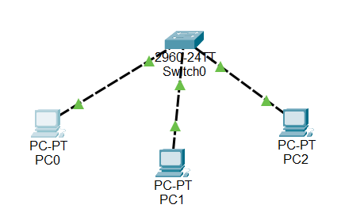

**Using ping command to generate traffic.**

**PC 0**

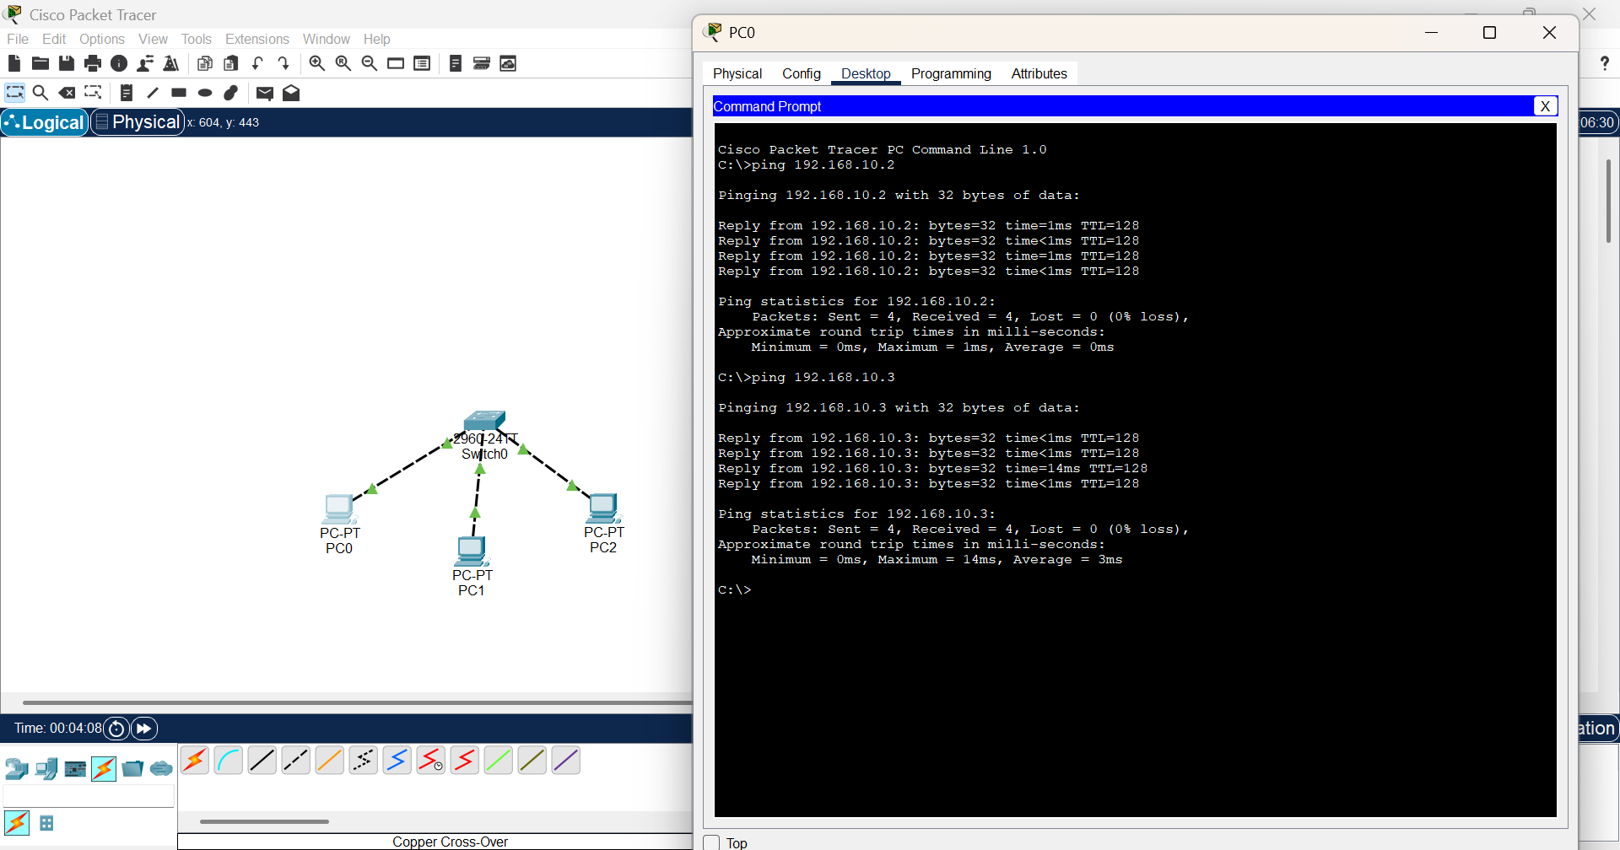

**PC 1**

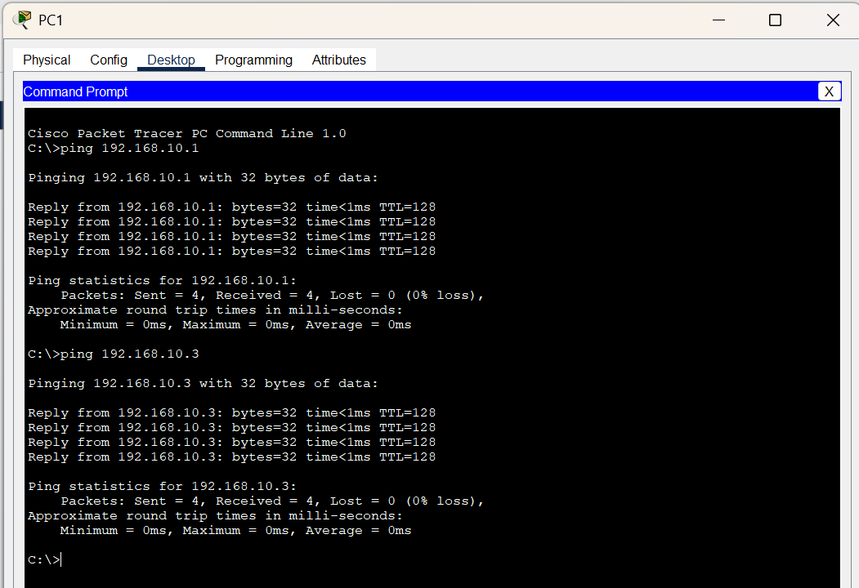

**PC 2**

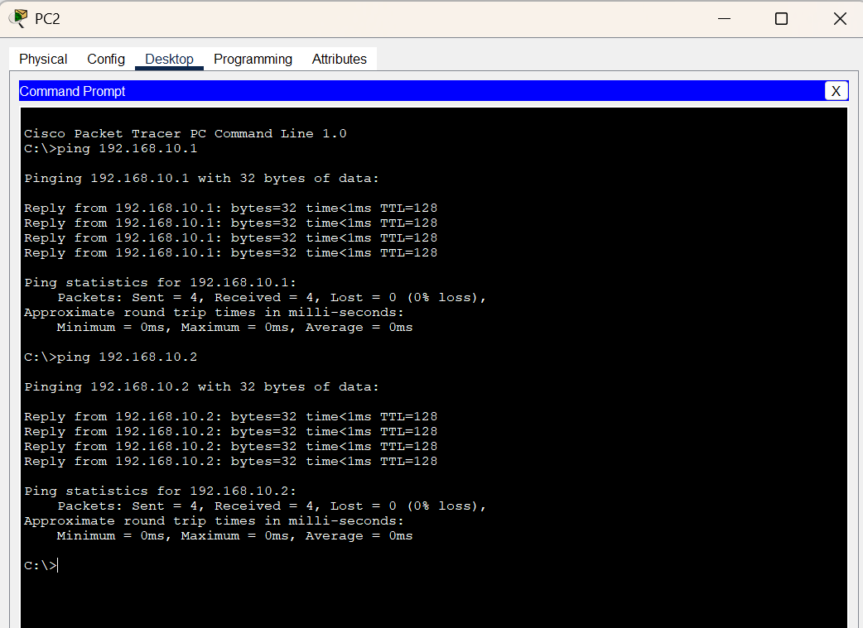

**Checking the MAC address table of the switch**

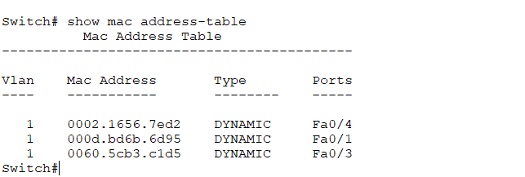

**Capturing packets using Wireshark:**

**Assigning ip to PC1:**

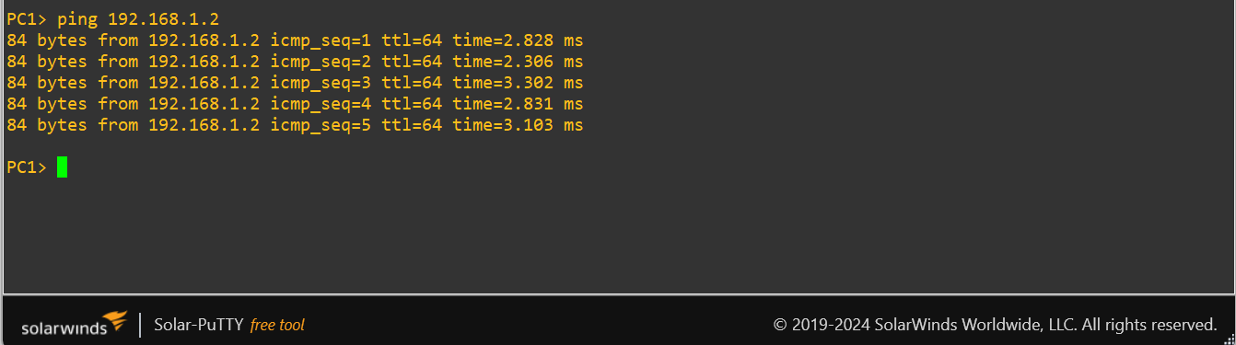

**Assigning ip to PC2:**

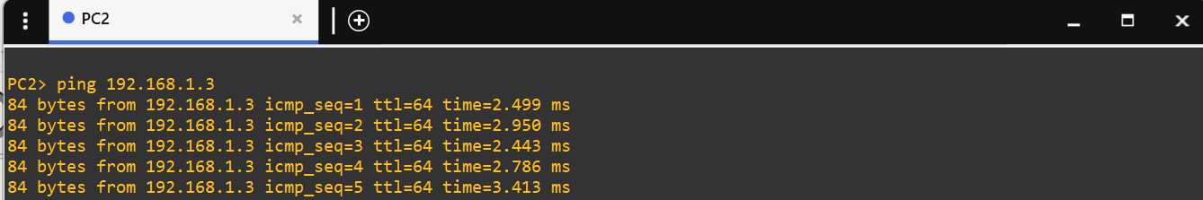

**Assigning ip to PC3:**

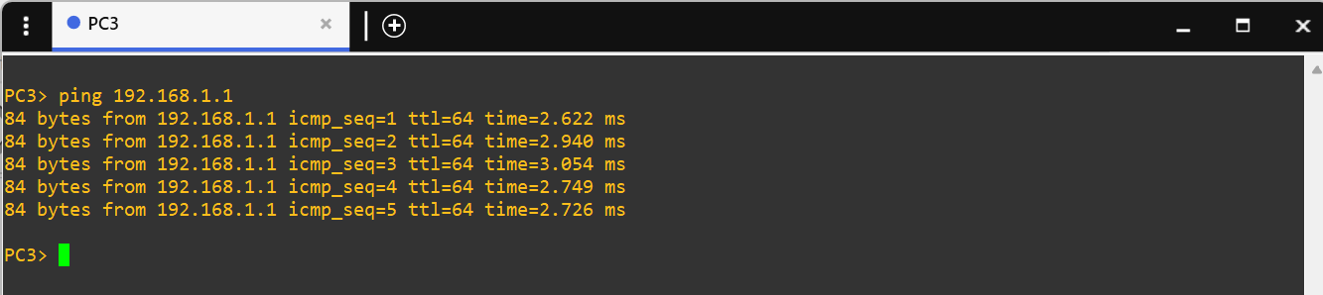

**Capturing packets by pinging the ip of PC2 in PC1:**

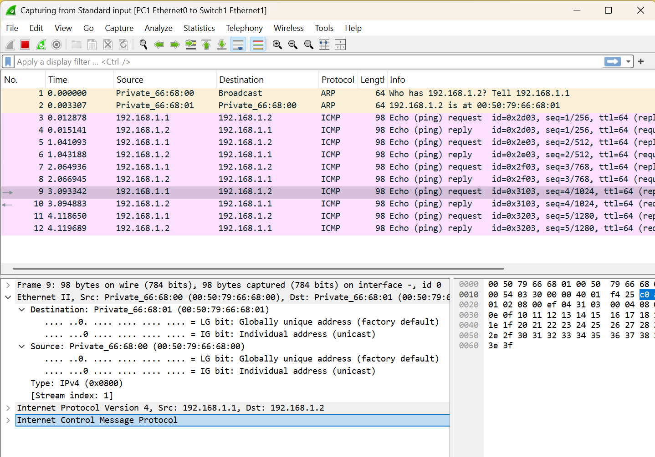

**Capturing packets by pinging the ip of PC2 in PC3:**

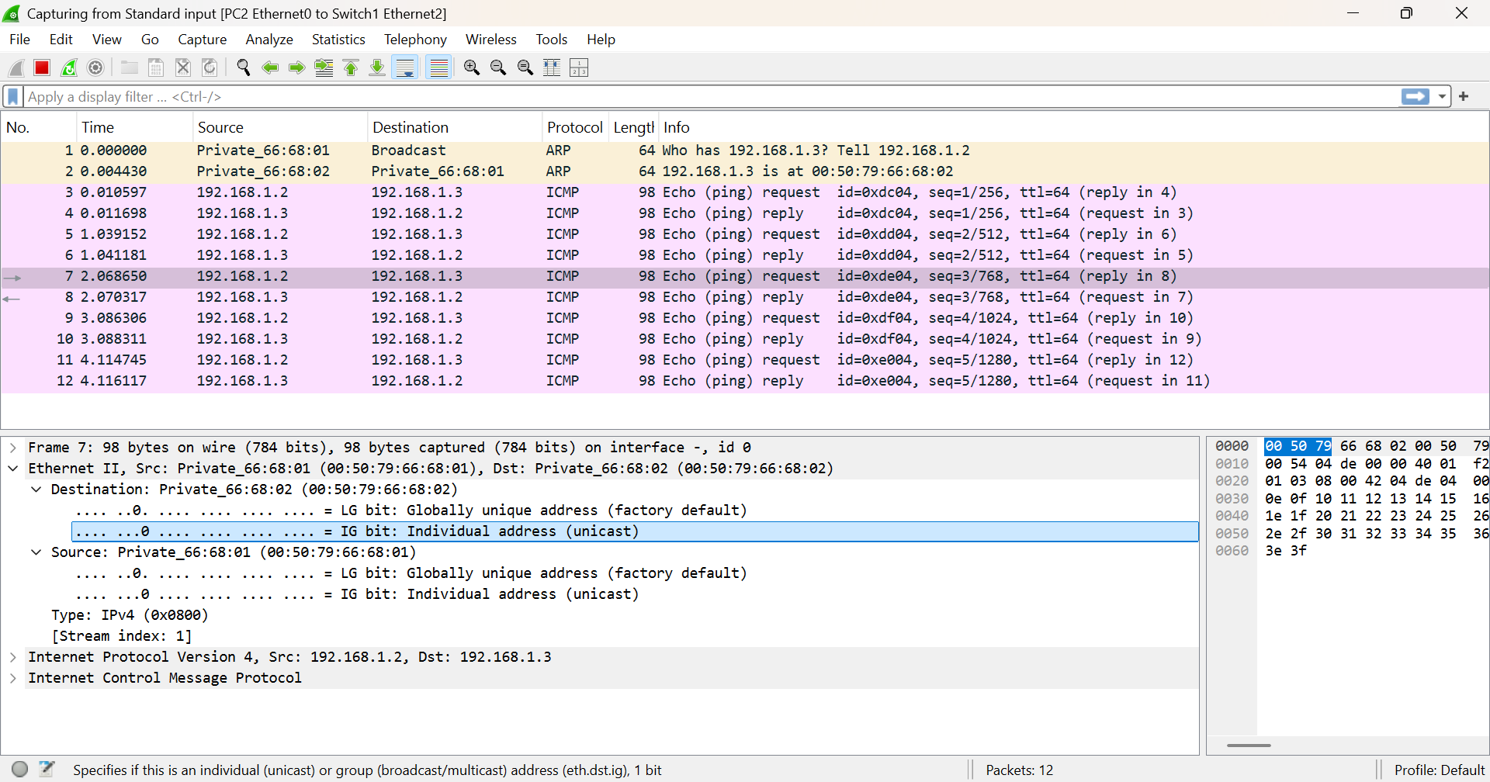

**Capturing packets by pinging the ip of PC3 in PC1:**

